Weekly Lesson Plan-Project Work
Date: July 28, 2014 Classroom: Red Room Study Topic: Healthy Bodies Phase: 3 Teachers: Ms. Bobotek and Mrs. Wiest
Discussion/Activity for Meeting Time  Let’s tie dye shirts for class color day on Friday. We will also run through the sprinkler so wear your swim suit.  What do we need for our culminating picnic celebration?  A fitness expert will come to teach us some new exercises.  We will culminate our study.  What was your favorite part of the Healthy Body study? What did you learn? | Fieldwork/Investigation for Center Time  Gross Motor: Monday we will have a sprinkler day.  Science- We will have a chance to learn from a Pilates instructor how to make our muscles stronger.  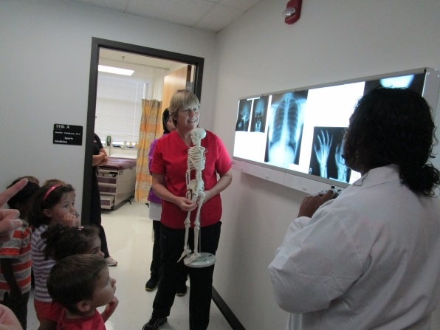 | Representation/Display  Culmination: Children will start to think of ways to culminate the Healthy Body study using technology.  Literacy: Children will write invitations to our culmination picnic celebration.  Technology- Students will share an iPad video that answers some of the questions they had during Phase I of our study.
Reminders: Wear your bathing suit Monday for sprinkler. Please take home extra belongs from your child’s cubbies because we will be cleaning the room this week.
Families are invited to come for lunch Thursday to see our culminating video. Please bring a lunch for yourself and your child.

Literature /Art: We will read books from our last Calldecott winning author, Peggy Rathmann including The Day the Babies Crawled Away, Good Night, Gorilla, and Officer Buckle and Gloria.
Mathematical Thinking: We will continue to measure ourselves and classroom items using tape measurers, rulers, and non-standard units of measurement.
Science- Campers will have a chance to look at x-rays using a light table.
Cooking: Children will decide on a dish to prepare for our culminating picnic.

